Religious Education Curriculum End Points
Area | EYFS | KS1 | LKS2 | UKS2
Making sense of beliefs | Feeds into KS1 end points | Identify core beliefs and concepts studied and give a simple description of what they mean.  Give examples of how stories show what people believe (e.g. the meaning behind a festival). Give clear, simple accounts of what stories and other texts mean to believers. | Identify and describe the core beliefs and concepts studied. Make clear links between texts/ sources of authority and the core concepts studied.  Offer informed suggestions about what texts/sources of authority can mean and give examples of what these sources mean to believers. | Identify and explain the core beliefs and concepts studied, using examples from texts/sources of authority in religions.  Describe examples of ways in which people use texts/sources of authority to make sense of core beliefs and concepts.  Give meanings for texts/sources of authority studied, comparing these ideas with some ways in which believers interpret texts/sources of authority.
Understanding the impact | Feeds into KS1 end points | Give examples of how people use stories, texts and teachings to guide their beliefs and actions.  Give examples of ways in which believers put their beliefs into practice. | Make simple links between stories, teachings and concepts studied and how people live, individually and in communities.  Describe how people show their beliefs in how they worship and in the way they live.  Identify some differences in how people put their beliefs into practice | Make clear connections between what people believe and how they live, individually and in communities.  Using evidence and examples, show how and why people put their beliefs into practice in different ways, e.g. in different communities, denominations or cultures
Making connections | Feeds into KS1 end points | Think, talk and ask questions about whether the ideas they have been studying, have something to say to them.  Give a good reason for the views they have and the connections they make. | Make links between some of the beliefs and practices studied and life in the world today, expressing some ideas of their own clearly.  Raise important questions and suggest answers about how far the beliefs and practices studied might make a difference to how pupils think and live.  Give good reasons for the views they have and the connections they make | Make connections between the beliefs and practices studied, evaluating and explaining their importance to different people (e.g. believers and atheists). Reflect on and articulate lessons people might gain from the beliefs/ practices studied, including their own responses, recognising that others may think differently.  Consider and weigh up how ideas studied in this unit relate to their own experiences and experiences of the world today, developing insights of their own and giving good reasons for the views they have and the connections they make.

Overview of Key Questions
Religion/Belief | EYFS (Discovering) | KS1 (Exploring) | LKS2 (Connecting) | UKS2 (Connecting)
 | Christianity plus others | Christians, Jews and Muslims | Christians, Muslims, Hindus and Jews
Christianity: God Creation Fall People of God Incarnation Gospel Salvation Kingdom of God | F1 Why is the word ‘God’ so important to Christians? [God]  F2 Why is Christmas special for Christians? [Incarnation]  F3 Why is Easter special for Christians? [Salvation] | 1.1 What do Christians believe God is like? [God].  1.2 Who do Christians say made the world? [Creation].  1.3 Why does Christmas matter to Christians? [Incarnation]  1.4 What is the ‘good news’  Christians believe Jesus brings? [Gospel]  1.5 Why does Easter matter to Christians? [Salvation] | L2.1 What do Christians learn from the creation story? [Creation/Fall]  L2.2 What is it like for someone to follow God? [People of God]  L2.3 What is the ‘Trinity’ and why is it important for Christians? [God/Incarnation]  L2.4 What kind of world did Jesus want? [Gospel]  L2.5 Why do Christians call the day Jesus died ‘Good Friday’? [Salvation]  L2.6 For Christians, what was the impact of Pentecost? [Kingdom of God] | U2.1 What does it mean if Christians believe God is holy and loving? [God]  U2.2 Creation and science: conflicting or complementary? [Creation]  U2.3 Why do Christians believe Jesus was the Messiah? [Incarnation]  U2.4 How do Christians decide how to live? ‘What would Jesus do?’ [Gospel]  U2.5 What do Christians believe Jesus did to ‘save’ people? [Salvation]  U2.6 For Christians, what kind of king is Jesus? [Kingdom of God]
Vocabulary | Bible, Christmas, Church, Easter, God, Harvest, Jesus, Prayer, Vicar | Advent, Baptism, Bible, Christ, Christmas, Church, Creation, Disciple, Easter, Faith, God, Harvest, Holy, Hymn, Jesus, Prayer, Priest, Vicar, Worship | Advent, Baptism, Bible, Christ, Christmas, Church, Creation, Disciple, Easter, Faith, God, Gospel, Harvest, Holy, Hymn, Jesus, Lent, New Testament, Old Testament, Parables, Pentecost, Prayer, Priest, Prophet, Ten Commandments, Vicar, Worship | Advent, Ascension, Baptism, Bible, Christ, Christmas, Church, Disciple, Easter, Faith, God, Grace, Harvest, Holy, Holy Spirit, Hymn, Jesus, Lent, Mass, Miracle, Prayer, Priest, Prophet, Psalm, Resurrection, Sin, Soul, Ten Commandments, Trinity, Vicar, Worship
Hinduism:  Samsara and moksha  Brahman (God) and atman  Karma and dharma |  |  | L2.7 What do Hindus believe God is like? [Brahman/atman]  L2.8 What does it mean to be Hindu in Britain today? [Dharma] | U2.7 Why do Hindus want to be  good? [Karma/dharma/samsara/  moksha]
Vocabulary |  |  | Aum or Om, Brahman, Diwali, Ganesh, Gods and goddesses, Hindu, Hinduism, Mandir, Offering, Pray, Rama, Shiva, Shrine, Sita, Vishnu, Worship, Dharma | Aum or Om, Brahman, Diwali, Gods and goddesses, Hindu, Hinduism, Pray, Rama, Shiva, Shrine, Sita, Vishnu, Worship, Karma, Dharma, Samsara,  Moksha
Islam:  God/Tawhid  Iman (faith)  Ibadah (worship)  Akhirah (life after death)  Akhlaq (virtue/morality) |  | 1.6 Who is a Muslim and how do they live? [God/Tawhid/ibadah/iman] | L2.9 How do festivals and worship show what matters to a Muslim? [Ibadah] | U2.8 What does it mean to be a  Muslim in Britain today?  [Tawhid/iman/ibadah]
 |  | Muslim, Islam, Allah, Prophet, mosque, Eid, Qur’an, Ramadan, Tawhid, Ibadah, Iman | Five Pillars of Islam, Mosque, Qur’an, Shahadah, Sawm, Zakat, Ramadan, Hajj, surah, paradise, Ibadah | Allah, Islam, Mosque, Muslim, Prophet, Quran, Tawhid, Iman, Ibadah
Judaism:  God  Torah  The People and  the Land |  | 1.7 Who is Jewish and how do they live? [God/Torah/People] | L2.10 How do festivals and family life show what matters to Jewish people?  [God/Torah/People/the Land] | U2.9 Why is the Torah so important to Jewish people? [God/Torah]
Vocabulary |  | Jewish, synagogue, Torah, Bimah, Chanukah/Hanukkah, Ark, Judaism, Shabbat, mezuzah, Tenakh | Synagogue, Torah Scrolls, Shabbat, Besamim (Spices), Challah, Havdalah, Havdalah candle, Kiddush Cup (goblet), Kosher, Bar Mitzvah/Bat Mitzvah, Chanukah, Rosh Hashanah, Shofar, Sukkah (Booth), Yom Kippur | Synagogue: Kippah, Menorah (Chanukiah), Star of David, Rabbi, Tallit, Torah Scrolls, Yad. Shabbat: Besamim (Spices), Kiddush Cup (goblet), Kosher, Two Candles, Wine, 24 Books of the written Torah, Bar Mitzvah/Bat Mitzvah, Egypt, Moses,
Non-religious worldviews |  |  |  | U2.10 What matters most to Humanists and Christians?
 |  |  |  | Humanist, Golden Rule, non-religious, agnostic, rationalist
Thematic | F4 What places are special and why?  F5 What times/stories are special and why?  F6 Being special: where do we belong? | 1.8 What makes some places sacred to believers?  1.9 How should we care for others and the world, and why does it matter?  1.10 What does it mean to belong to a faith community? | L2.11 How and why do people mark the significant events of life?  L2.12 How and why do people try to make the world a better place? | U2.11 Why do some people believe in God and some people not?  U2.12 How does faith help when life gets hard?
General Vocabulary | Religion, Special books, Special places, Special stories, Prayer | Religion, celebration, festival, symbol, thankful, faith, belief, wise sayings, rules for living, cooperation, belonging, worship, holiness, sacred, creation story | Spiritual, commitment, values, prayer, pilgrim, pilgrimage, ritual, community, devotion, life after death, destiny, soul, inspiration, role-model | Harmony, respect, justice, faith, interfaith, tolerance, moral values, religious plurality, moral codes, vision, sources of wisdom, Golden Rule, charity, place of worship, sacred text, compassion, prejudice, persecution, teachings, diversity and expression

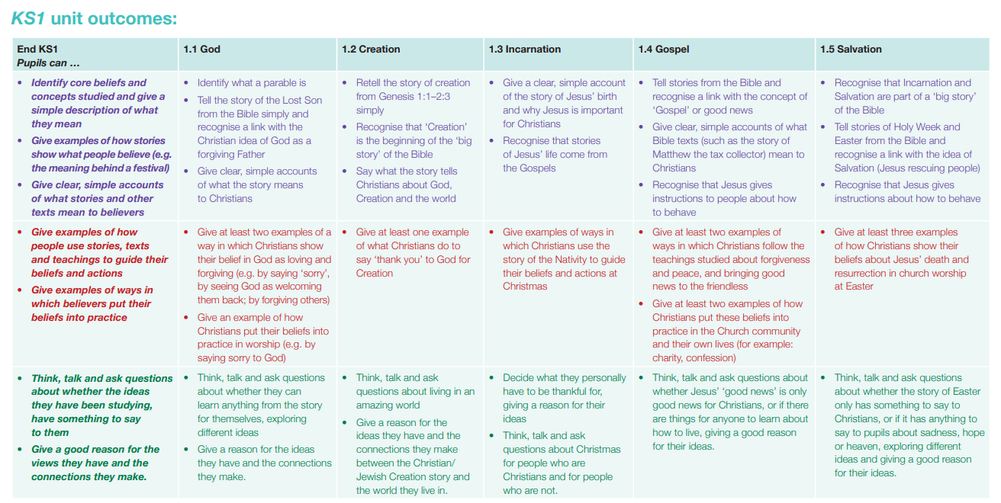

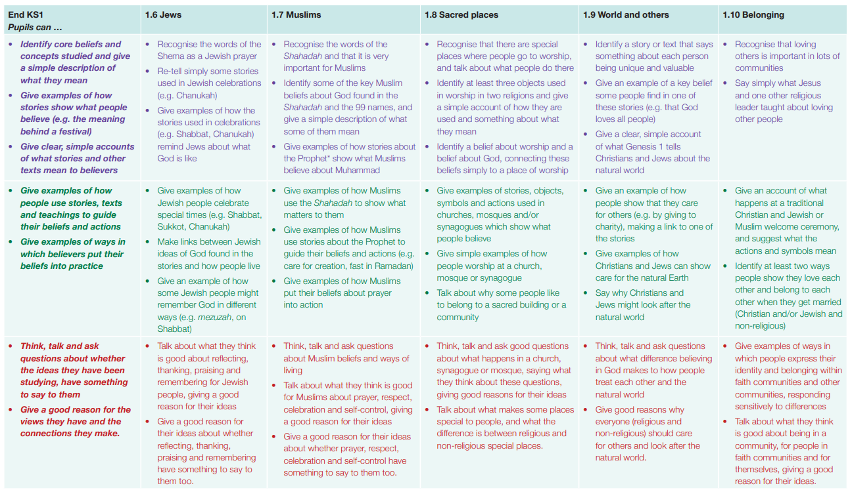

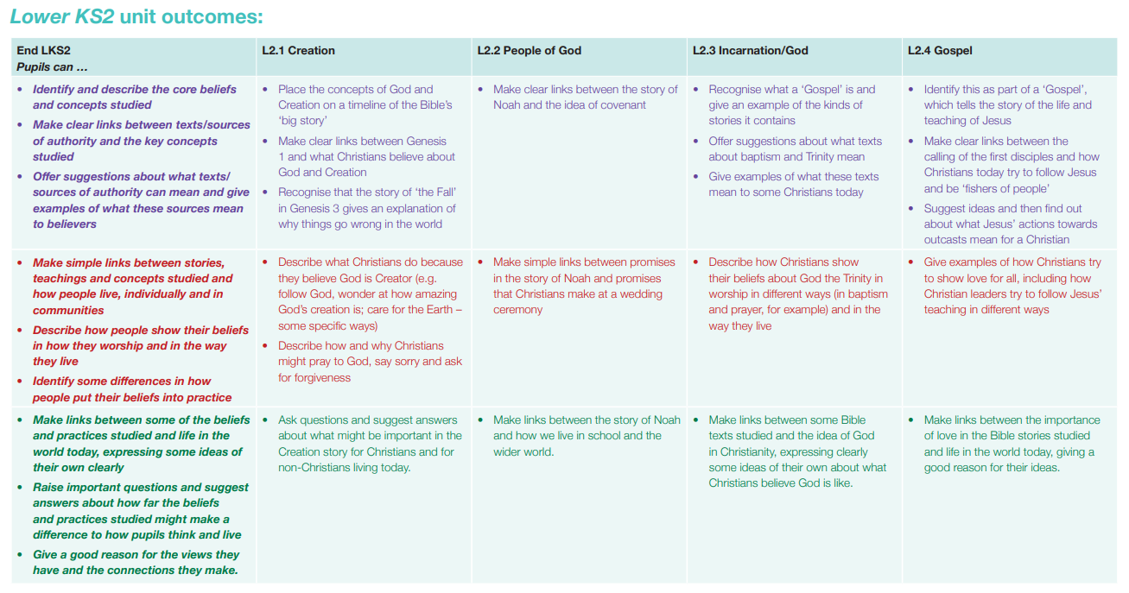

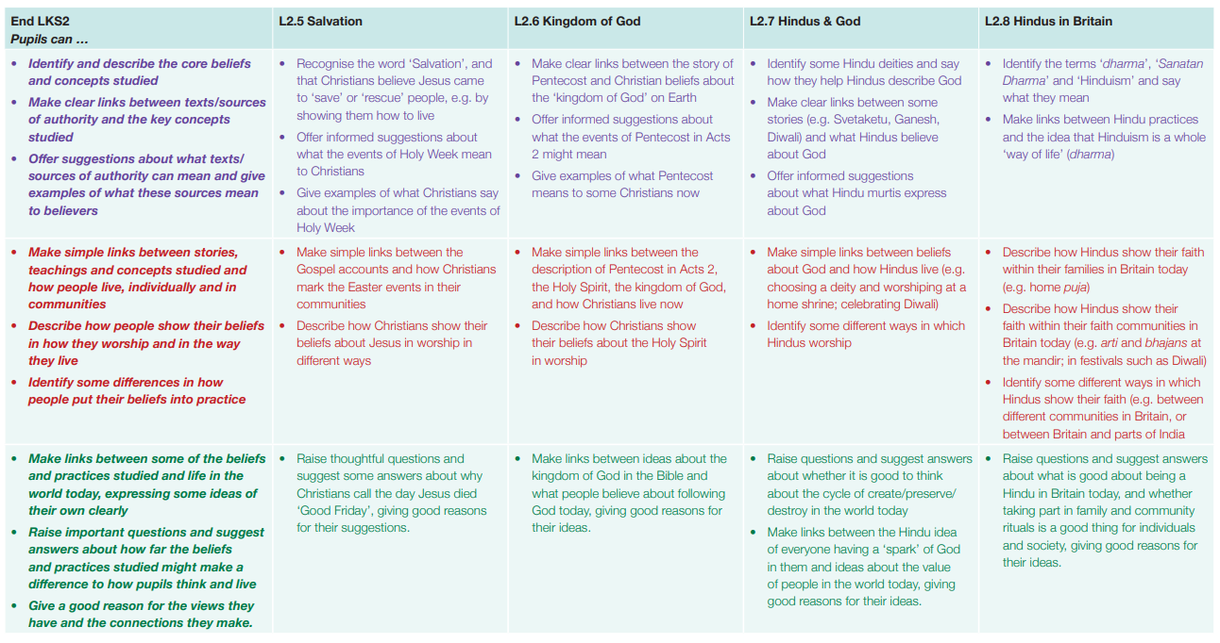

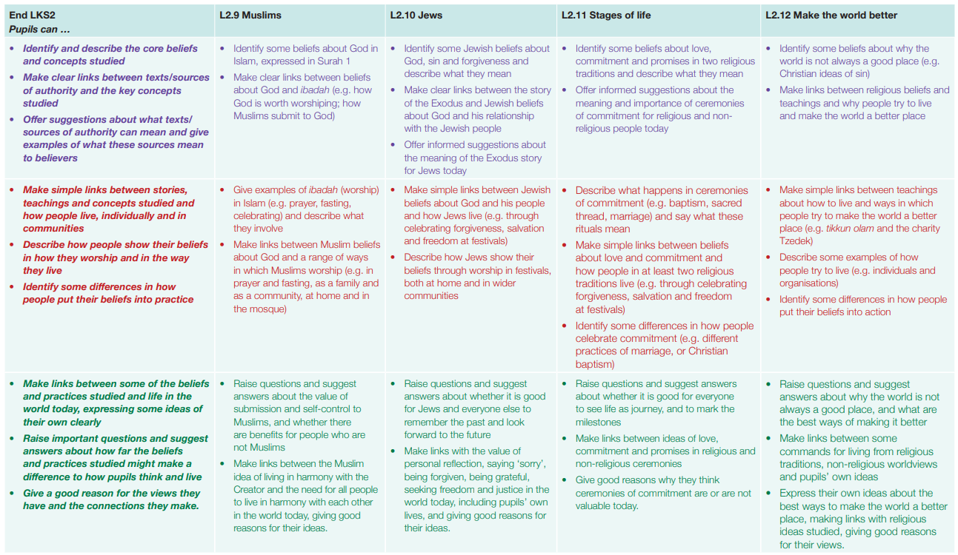

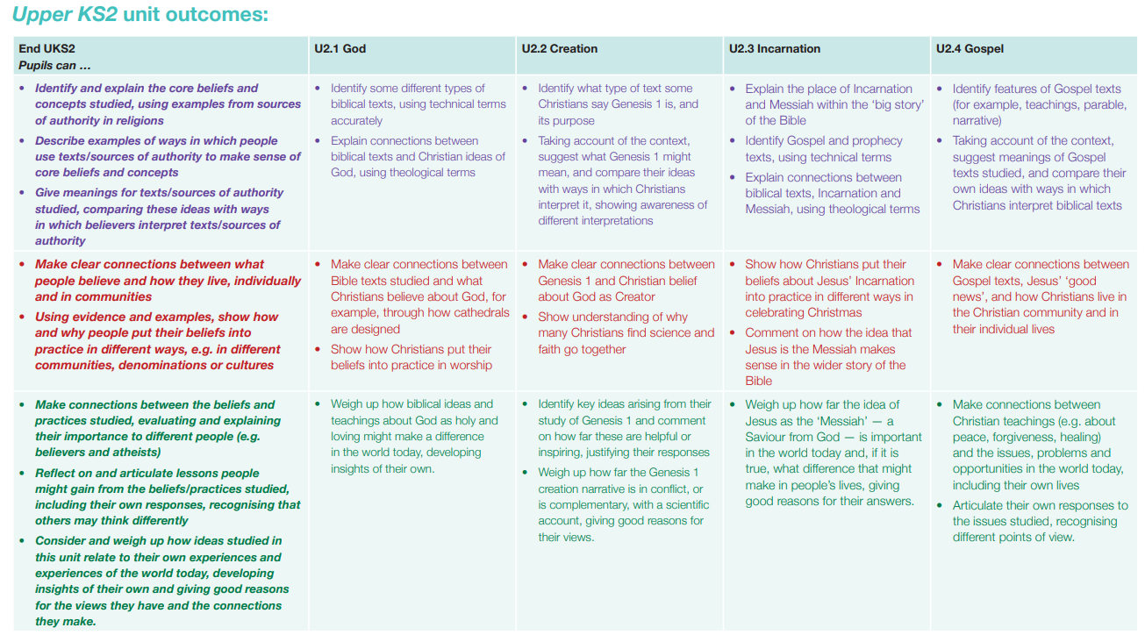

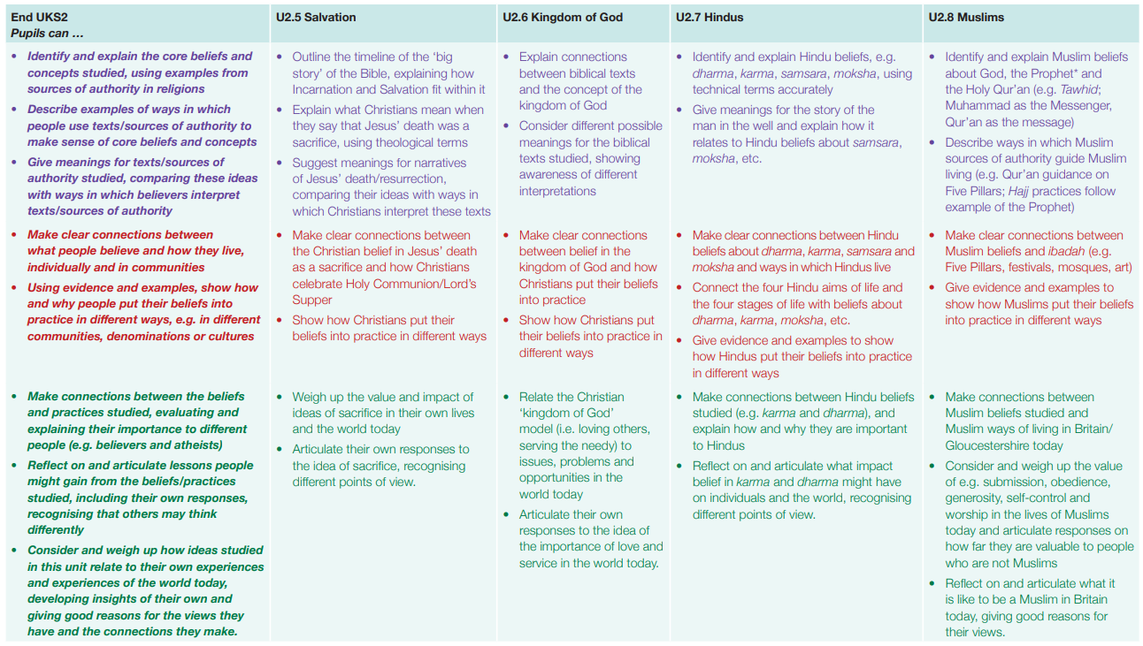

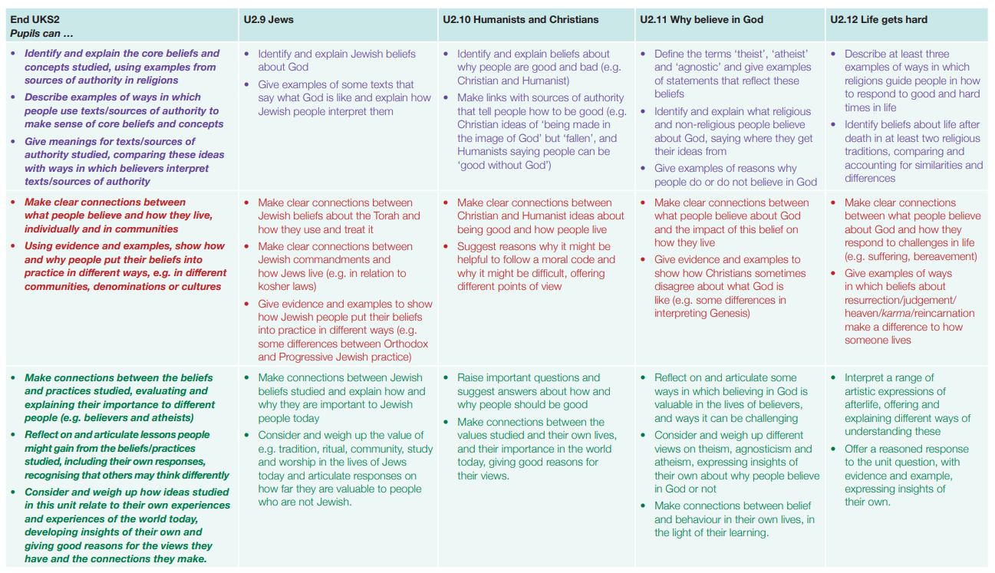

EYFS |  |  | KS1 |  |  | LKS2 |  |  | UKS2
Children working above EXS |  |  | Children working above EXS |  |  | Children working above EXS |  |  | Children working above EXS
Children working below EXS |  |  | Children working below EXS |  |  | Children working below EXS |  |  | Children working below EXS
% below EXS | % at EXS | % above EXS | % below EXS | % at EXS | % above EXS | % below EXS | % at EXS | % above EXS | % below EXS | % at EXS | % above EXS
How have the needs of those working below expectations been met? |  |  | How have the needs of those working below expectations been met? |  |  | How have the needs of those working below expectations been met? |  |  | How have the needs of those working below expectations been met?
What has taken children beyond the curriculum? (i.e. theme days, trips, visitors) |  |  | What has taken children beyond the curriculum? (i.e. theme days, trips, visitors) |  |  | What has taken children beyond the curriculum? (i.e. theme days, trips, visitors) |  |  | What has taken children beyond the curriculum? (i.e. theme days, trips, visitors)

