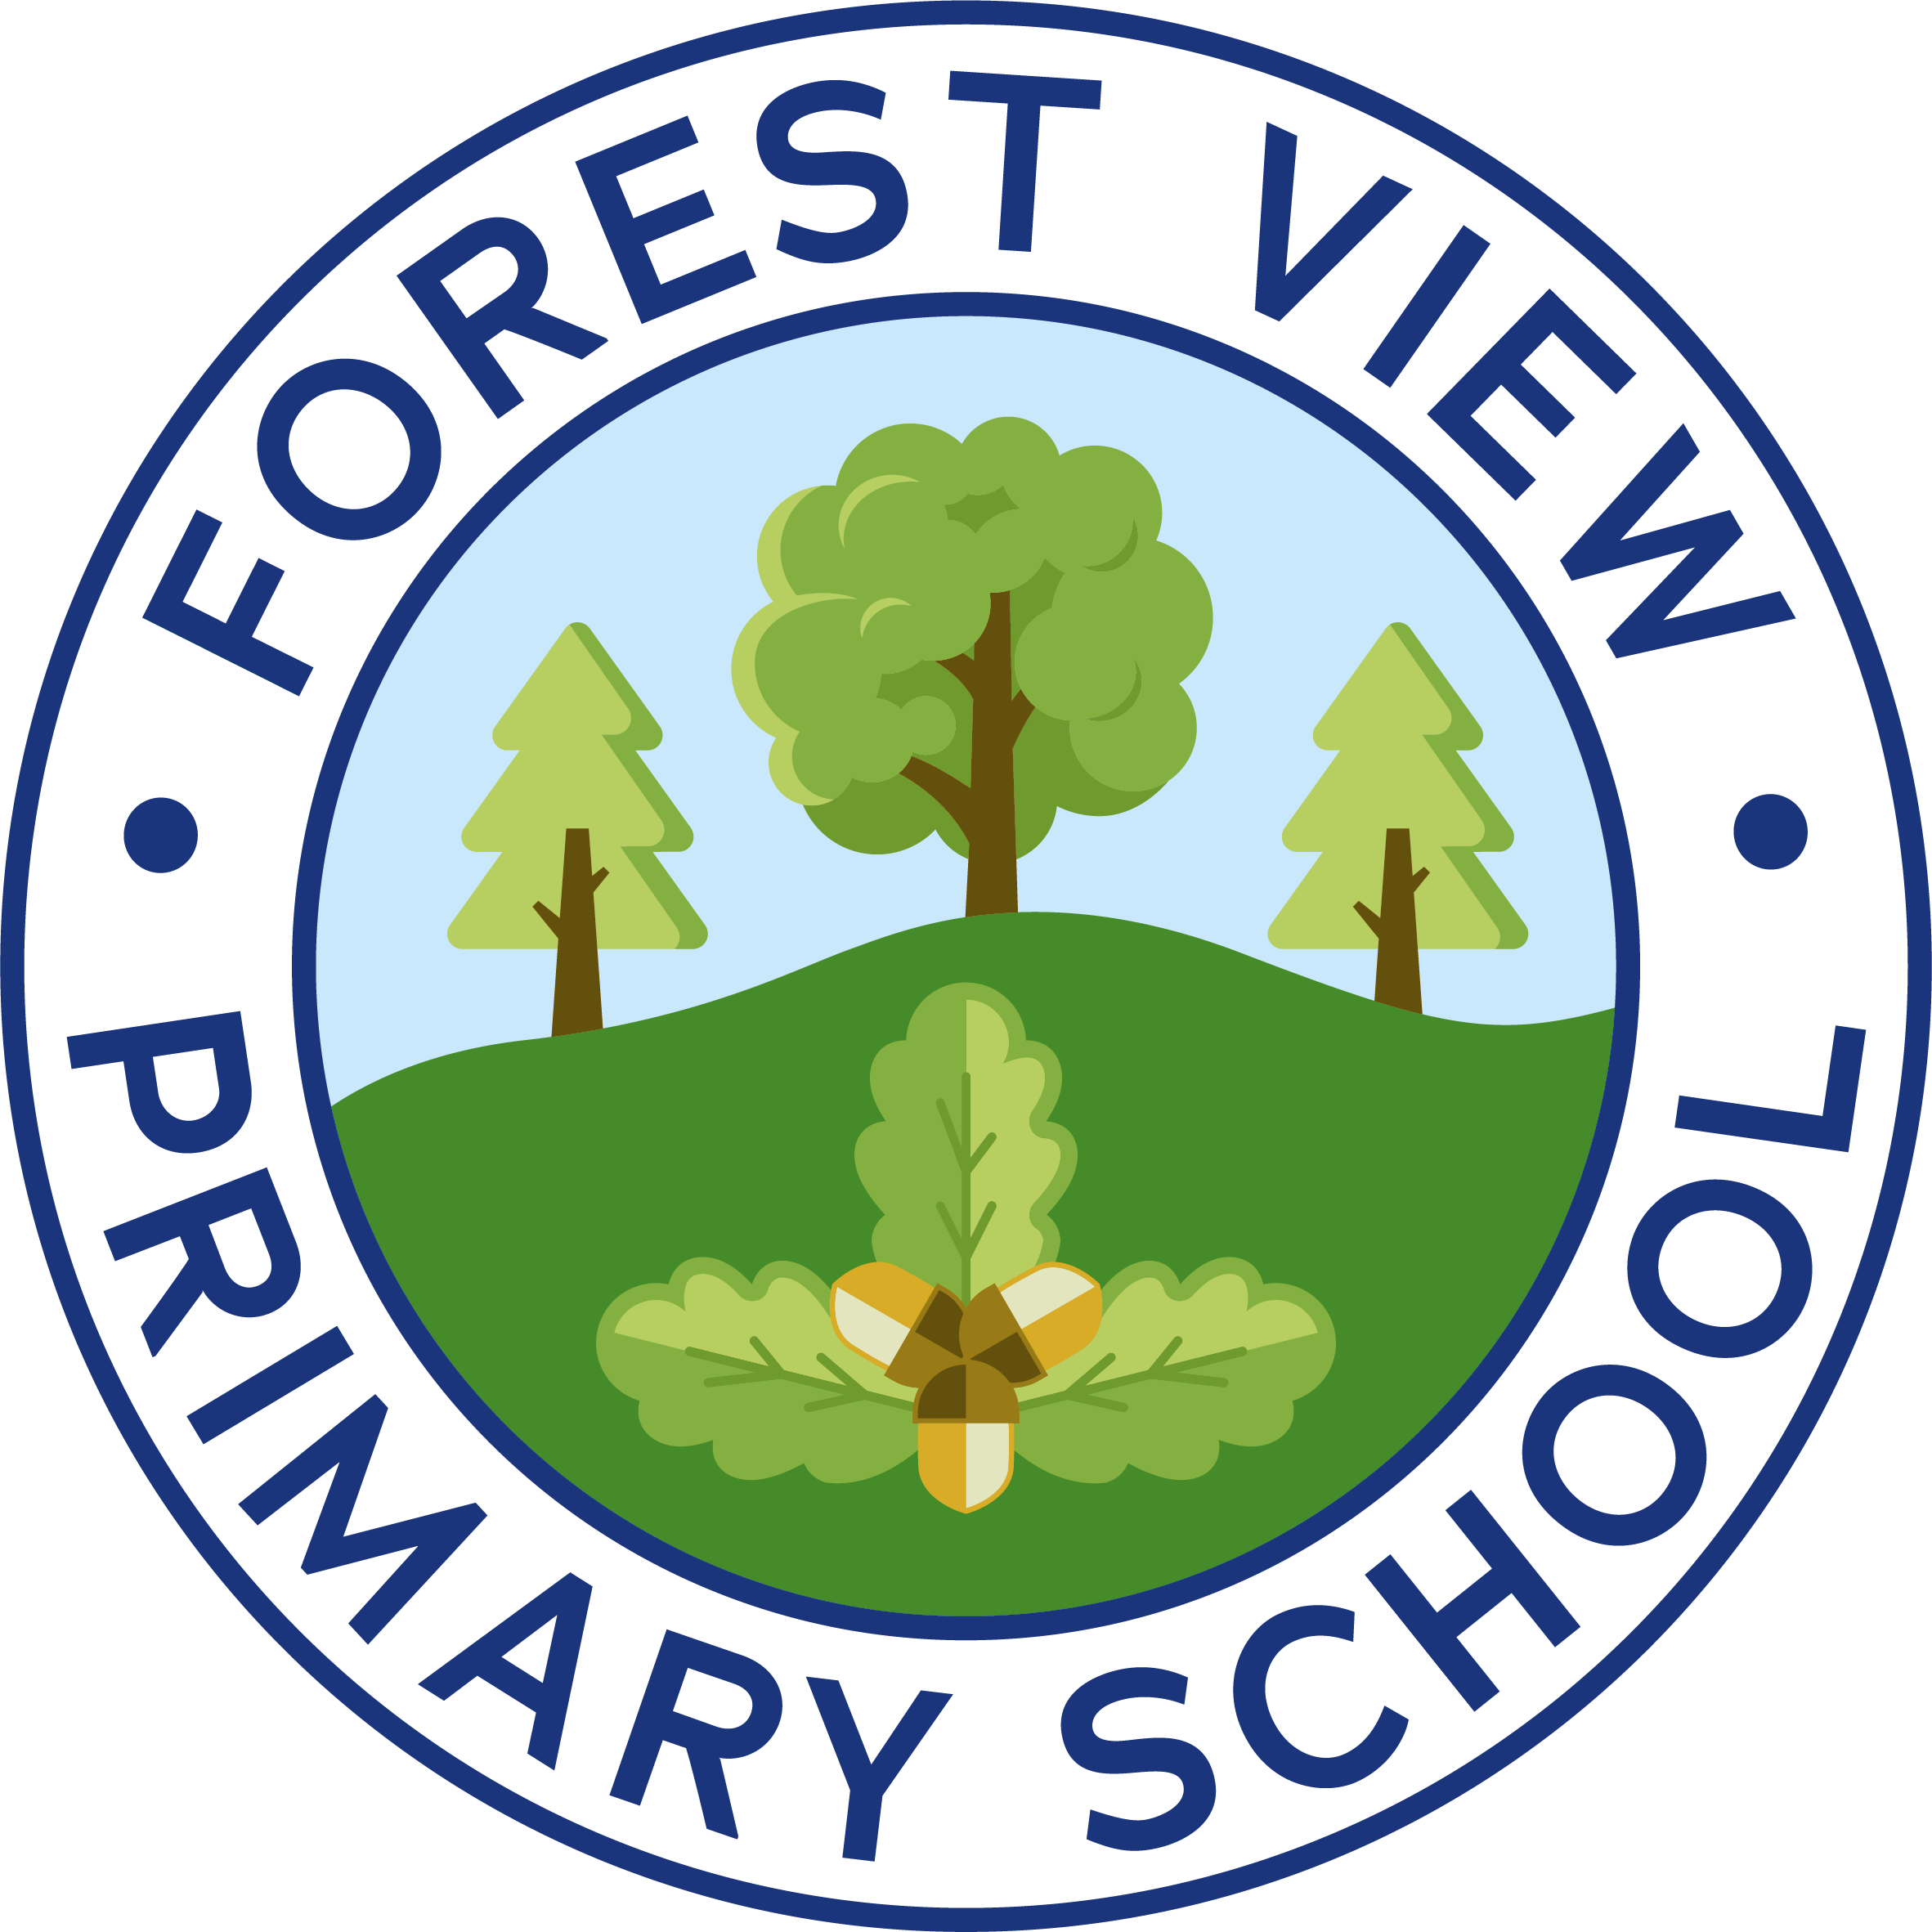
Forest View Primary School
Subject Progression Map – Science

1. Intent
Subject vision (why this matters for Forest View) | Science teaching at Forest View aims to develop curiosity, critical thinking, and a secure understanding of scientific concepts. We want pupils to ask questions, explore, and apply scientific knowledge to real-world contexts, preparing them for future learning and life.
Local context drivers & cultural capital | Hands-on investigations; outdoor learning in Forest School; links to sustainability projects (bee hives, orchard, eco initiatives); STEM enrichment days.
Links to school values & British Values | Promotes resilience through problem-solving; respect and tolerance in collaborative experiments; democratic participation in group investigations.
Inclusion intent (SEND/EAL/PP/Bottom 20%) | Adaptive teaching ensures all pupils access age-related content; scaffolds include visuals, sentence stems, practical resources; targeted interventions for vocabulary and concept gaps.
Scientific threads | Working scientifically embedded across topics; vocabulary explicitly taught; enquiry skills developed progressively.

2. Sequencing Overview- see endpoints and curriculum maps
Phase | Core knowledge | Key skills | Key vocabulary | Connected threads
EYFS | Explore natural world; observe changes; simple properties | Ask questions; describe observations | Names of common plants/animals; simple descriptive words | Linked to outdoor learning and sensory play
KS1 | Identify and classify everyday materials; seasonal changes; basic life cycles | Perform simple tests; record findings | Material names; seasons; parts of plants | Talk for science; link to reading and writing PSHE (healthy eating) Geography (habitats) DT (materials)
LKS2 | States of matter; sound; electricity; habitats; nutrition | Plan investigations; measure accurately; use tables/charts | Scientific terms: evaporation, circuit, predator/prey | Cross-curricular links with maths (data) geography, PE (healthy eating)
UKS2 | Forces; light; evolution; reproduction; properties of materials | Control variables; interpret data; draw conclusions | Advanced vocabulary: refraction, inheritance, adaptation | Maths for data handling; English for report writing; geography for habitats; PSHE for reproduction, healthy eating; PE for exercise; Computing for data handling and research. DT (materials, forces)

3. Phase Endpoints- see endpoint document for more detail
Phase | Endpoints | Typical assessments | Non-examined evidence
EYFS | Show curiosity; talk about observations; know common plants/animals | Observation against ELGs | Photographs; teacher notes
KS1 | Name materials; describe properties; observe seasonal changes | Teacher assessment; quizzes, retrieval questions, TAPPS assessments, practical write-ups | Science journals; annotated drawings
LKS2 | Explain states of matter; describe habitats; construct simple circuits | Teacher assessment; quizzes, retrieval questions, TAPPS assessments, practical write-ups | Charts; group presentations
UKS2 | Apply scientific vocabulary; design fair tests; explain conclusions | End-of-KS assessments  Teacher assessment; quizzes, retrieval questions, TAPPS assessments, practical write-ups | Reasoning journals; project work

4. Implementation & Monitoring
Schemes/resources | National Curriculum; school progression documents; practical kits; outdoor learning resources. TAPPS assessment. Co-pilot AI
Teaching approaches | Enquiry-based learning; hands-on investigations; use of Forest School for science contexts.
Assessment schedule | TAPPs assessments used with each unit; retrieval questions every lesson, ongoing formative checks; moderation across phases.
Monitoring | Learning walks; book scrutiny; pupil voice; monitor seesaw trust QA visits.
CPD priorities | Working scientifically; adaptive scaffolds; vocabulary teaching strategies.
Workload management | In-the-moment feedback; streamlined planning templates; shared resources.

5. Inclusion & Adaptation
Adaptive scaffolds | Visual aids; sentence stems; practical resources; vocabulary mats.
Interventions | Pre-teach vocabulary; small-group concept reinforcement; speech and language support.
Access arrangements | Additional time; simplified instructions; bilingual support.
Cross-curricular support | Maths for data handling; English for report writing; geography for habitats; PSHE for reproduction, healthy eating; PE for exercise; Computing for data handling and research. DT (materials, forces)
Equality & protected characteristics | Contexts and examples reflect diverse cultures and contributions to science.

6. Impact & Next Steps
Recent outcomes | Improved engagement in practical science; stronger vocabulary evident in books; positive pupil voice feedback.
Changes after monitoring | Embedded enquiry-based approach; increased outdoor learning; improved use of scientific vocabulary.
Risks/issues | Variability in teacher confidence; gaps in prior knowledge; limited home science experiences. Resourcing activities
SMART next steps | Aut1: Launch science CPD; monitor use of vocabulary mats in all classes.  Spring 1: Monitor enquiry tasks; collect pupil voice data.  Spr 2: Host science week; showcase investigations.  Sum1: Review progression map; update endpoints.  Sum2: Evaluate impact; report to governors.

