
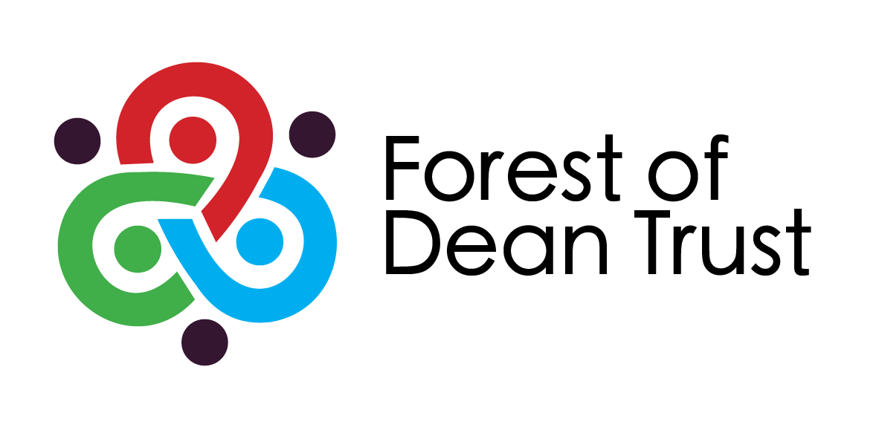

PHSE and Citizenship Policy

FOREST VIEW SCHOOL

Policy name | PHSE and Citizenship Policy
Version date | September 2025
Owner | BL
Approval date | September 2025
Approver | Local Governing Board
Review frequency | As required
Review date | As required

Introduction

This policy is in addition to the Foundation Subject Policy and PSHE curriculum statement and should be read in conjunction with that policy.

At Forest View Primary School we believe that education should support the academic, social, physical and spiritual development of our children and give them the opportunity to develop the skills which enable them to become lifelong learners. We believe that in order for our children to achieve their best, they need a broad curriculum and an atmosphere where challenge, pride in achievement and a positive, problem solving ‘have a go’ attitude are celebrated and where they receive the support and guidance which help them develop attitudes which are tolerant, considerate and accepting of others.

Aim

Our aim is for Forest View Primary School to be central to the community and to reflect the values and heritage of its community.

PSHE stands for Personal, Social and Health Education.

Successful PSHE and Citizenship education is achieved through a variety of forms:

- Discrete curriculum time.
- Teaching PSHE and citizenship through and in other subjects/curriculum areas.
- Through PSHE and citizenship activities, school events, visits and visitors.

We recognise that a combination of these is needed for a whole school approach.

Objectives

Our objectives in teaching PSHE are:

- To establish opportunities for increased pupil involvement in the life of the school.
- To help our children to develop self-confidence and a feeling of worth.
- To encourage our children to make healthy, informed choices about their lives.
- To help pupils identify ways of responding to peer group pressure.
- To develop a caring and considerate attitude towards themselves and others.
- To develop a caring attitude to the environment.
- To help our pupils to understand and manage their feelings.
- To understand how society works and their rights and responsibilities.
- To learn about British Values.

Children will be taught:

- Through separately timetabled time for PSHE and Citizenship
- In circle time sessions
- Through Pastoral Care groups
- In combination with other subjects, and in English and Maths Lessons

Provision for P.S.H.E. and Citizenship will also be provided during Assemblies, Extra Curricular Activities, visits, visitors, School Council meetings, playtimes and special events in the school.
Planning

Classes will follow the long-term school plans.

They will use the GHLL curriculum and resources and the End Points document.

Inclusion

Every effort will be made by teachers to include all children in every lesson regardless of ability, responding to pupils’ diverse needs and setting suitable challenges.

Teachers will use a variety of techniques to include all children.

Teaching Strategies (refer to Teaching and Learning Policy)

A balanced range of teaching strategies is needed to provide for the effective delivery of PSHE for all children.

We emphasis active learning and participation, where children are encouraged to assess evidence, negotiate, make decisions, solve problems, work independently and in groups, and to learn from each other.

