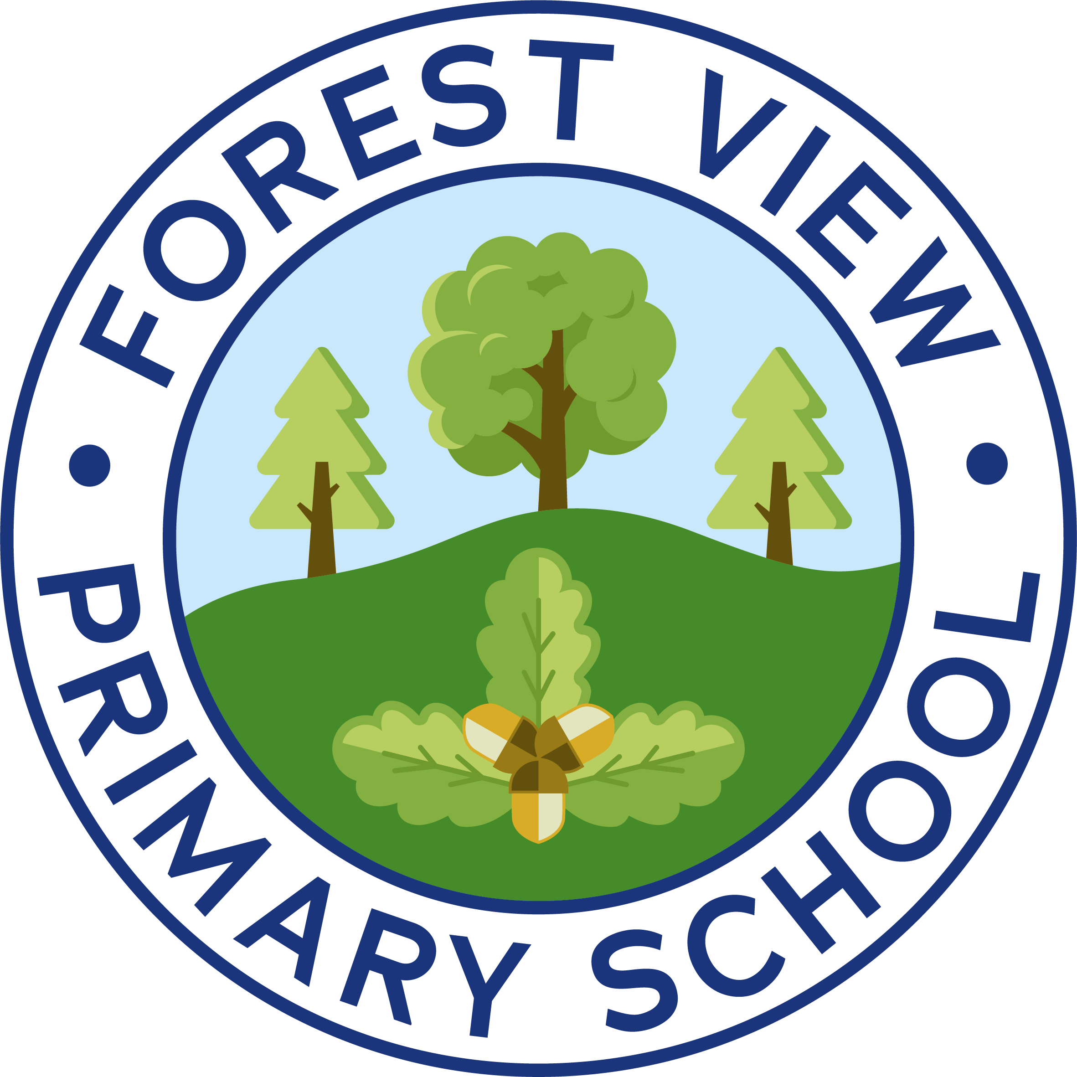


RE Policy

FOREST VIEW SCHOOL

Policy name | RE Policy
Version date | September 2025
Owner | BL
Approval date | September 2025
Approver | Local Governing Board
Review frequency | As required with curriculum updates
Review date | As required

Additional information to supplement generic foundation subject policy

Forest View Primary School fosters strong links with our local community in working together to provide rich learning opportunities for our pupils. The ethos of our school provides a welcoming, secure and stimulating environment and is reflected in a religious education programme that is inclusive and relevant to the spiritual, moral, social and cultural development of all our pupils.

Parents have a legal right to withdraw their children from religious education.

What we believe

RE is fundamentally concerned with an exploration of the important aspects of life and what it’s like to be human. It provides opportunities for pupils to ask questions seek answers and develop ideas in a quest to discover more about their own identity and that of others. RE can provide a context for the exploration of moral and ethical opinions and dilemmas by learning about lifestyles and behaviour in real, historical and fictional situations. It can help our pupils to understand the power and meaning of belief and religion for individuals and communities in the United Kingdom and across the world.

Within their learning in RE, pupils develop specific attitudes that are open, reflective, and critical and a skill base which allows them to be curious, play with ideas, empathise, listen, imagine, question, make links and reason. They need to appreciate the ‘uncomfortableness’ of the unknown.

Religious Education Curriculum Planning (See Curriculum Policy)

RE at our school follows ‘The Gloucestershire Agreed Syllabus’ linking into our topics wherever possible.

