Seesaw Pupil Log in
In the Apple or Android store search for the ‘Seesaw class app’. Select ‘Seesaw Class’.
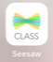
Open the App and select ‘I’m a Student’.
Alternatively, on a computer go to https://app.seesaw.me
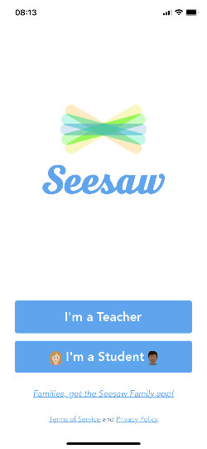
Scan your pupil Home Learning QR code or type the letters into the ‘TEXT CODE’ box. Your codes are personal to you and like a password so keep them safe!
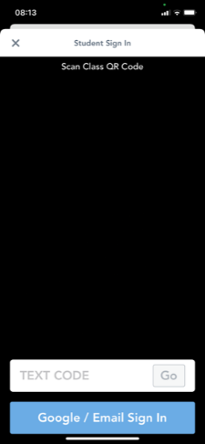.
You should now have access to your Seesaw account. You will see your name and class displayed at the top of your screen.
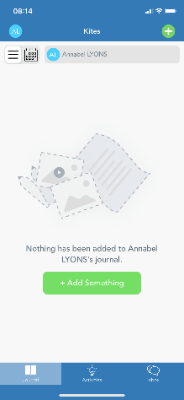
To add work to your learning journal.
Select ‘Journal’ from the bottom toolbar. Then press the green ‘+ Add Something’ button or the green ‘+’ in the top right hand corner of the screen.
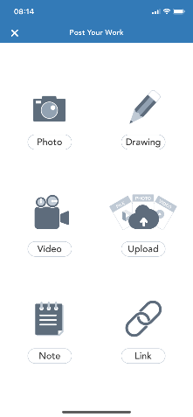
Choose the type of work that you want to add to your Journal.

See what work your teacher has set for you by selecting ‘Activities’ from the bottom toolbar.
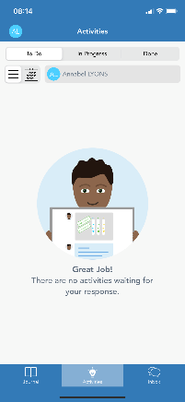
Your teacher can set and the mark the work that you have completed. They can even leave audio messages for you! You can talk back to your teacher by leaving your own audio message.

Once you have completed a piece of work, click on the green tick in the top right hand corner of your screen to publish the work and send it back to your teacher.

Go to the ‘Inbox’ on the bottom toolbar to see class messages and notifications.
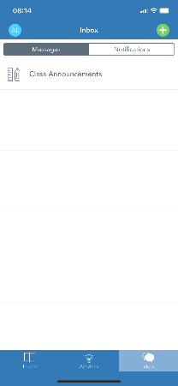
Choose ‘Class Announcements’ to see your class messages

