
Forest View E-Safety Guidance

Top Tips
- Put yourself in control – use parental controls on your home broadband and any internet-enabled devices (use the useful websites below for more help on how to do this.)
- Search safely – use safe search engines and enable safe search settings on your most used search engines.
- Agree boundaries – be clear with your children about what they can and can’t do online, where they can use the internet and how much time they spend online.
- Check suitability – the minimum age rating for most social media apps is 13 (check apps, games and websites your child uses using the useful websites below.)
- Teach your children simple rules to follow online – the SMART rules below are used in school during e-safety lessons and provides an easy way to stay safe online.
- Stop, block, report – make sure you and your children are familiar with report and block functions of the range of apps, games and websites they use (find help with this in the useful websites below.)
- Allow your children to have fun online – encourage open conversations and honesty when using the internet. Find apps, games and websites your children can use to enjoy safely at home!

SMART Rules
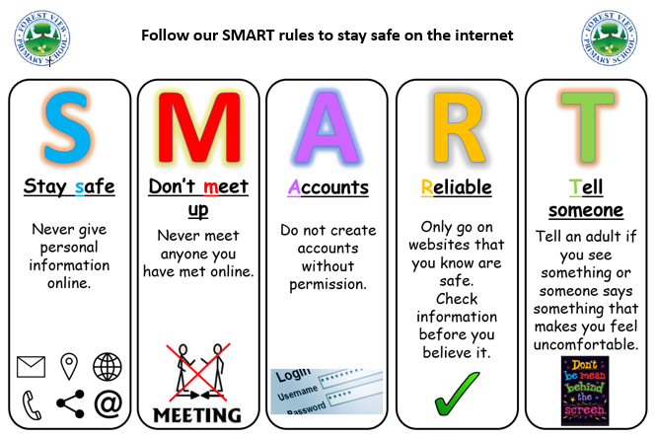

Useful Websites
www.thinkuknow.co.uk
www.internetmatters.org
https://www.childnet.com/resources/digiduck-stories
https://www.childnet.com/resources/smartie-the-penguin
https://www.net-aware.org.uk/news/age-content-ratings-apps-games/
https://www.bbc.com/ownit/curations/need-answers
https://www.childline.org.uk/info-advice/bullying-abuse-safety/online-mobile-safety/staying-safe-online/
https://www.childnet.com/resources/how-to-make-a-report

